June 29, 2017

Specialized Press Contact
Janusz Berger
Communication Manager
High Performance Polymers
Phone +49 2365 49-9227
janusz.berger@evonik.com

Evonik Resource Efficiency GmbH
Rellinghauser Straße 1-11
45128 Essen
Germany
Phone +49 201 177-01
Fax +49 201 177-3475
www.evonik.com

Supervisory Board
Dr. Ralph Sven Kaufmann, Chairman

Executive Board
Dr. Claus Rettig, Chairman
Dr. Johannes Ohmer,
Simone Hildmann,
Alexandra Schwarz

Registered Office: Essen
Register Court: Essen Local Court
Commercial Registry B 25783
VAT ID no. DE 815528487
Evonik and SINOPEC to collaborate in OSN membrane technology

The German specialty chemicals company Evonik Industries AG and the SINOPEC Beijing Research Institute of the Chemical Industry (BRICI) have signed a collaboration agreement to build a process development laboratory for Organic Solvent Nanofiltration (OSN) membrane technology.

Based on its solid technical expertise and comprehensive OSN product portfolio, Evonik will act jointly with BRICI to develop new processes for Sinopec. “Starting up the OSN lab is a consistent step in our growth plan for the attractive membrane business,” notes Dr. Dominic Stoerkle, Vice President & General Manager of the High Performance Polymers Business Line Asia Pacific at Evonik. “Based on the close partnership with BRICI and our active participation in the open platform, we anticipate further growth to result from the new joint OSN laboratory."

Professor Li Hongbo, president of the Yanshan Branch of Sinopec BRICI, particularly emphasized his organization’s willingness to enter into a more extensive cooperation with Evonik: “The joint OSN laboratory is a novel approach to fostering collaboration. It is well aligned with our regional innovation strategy and future development vision. Evonik will contribute advanced technology, which SINOPEC will make accessible to various business stages. With Evonik’s support, we will also build up a pilot plant unit in one of Sinopec’s production sites as an OSN reference plant.”

Founded in1958, SINOPEC Beijing Research Institute of the Chemical Industry (BRICI) is a pioneering institution in China dedicated to comprehensive research for the petrochemical industry. When Evonik initiated the first contact with BRICI in 2015, both parties showed strong interest in potential OSN applications for the petrochemical industry. In the following year, a series of laboratory-scale tests were successfully conducted for a lube oil dewaxing application. To enter into a partnership with the aim of developing more processes and setting up a long-term collaboration, both sides initiated several management-level meetings to discuss a future collaboration strategy. The joint OSN laboratory was officially established in early 2017, when Evonik’s first (lab-scale) equipment arrived at SINOPEC BRICI.

In the future, the laboratory will focus on the petrochemical industry to open up substantial markets in both China and the entire Asian region for OSN applications.

What is OSN?
Organic Solvent Nanofiltration (OSN) is an innovative and environmentally friendly membrane technology, which has a wide range of applications in the petrochemical, pharmaceutical, fine chemicals, and food industry.
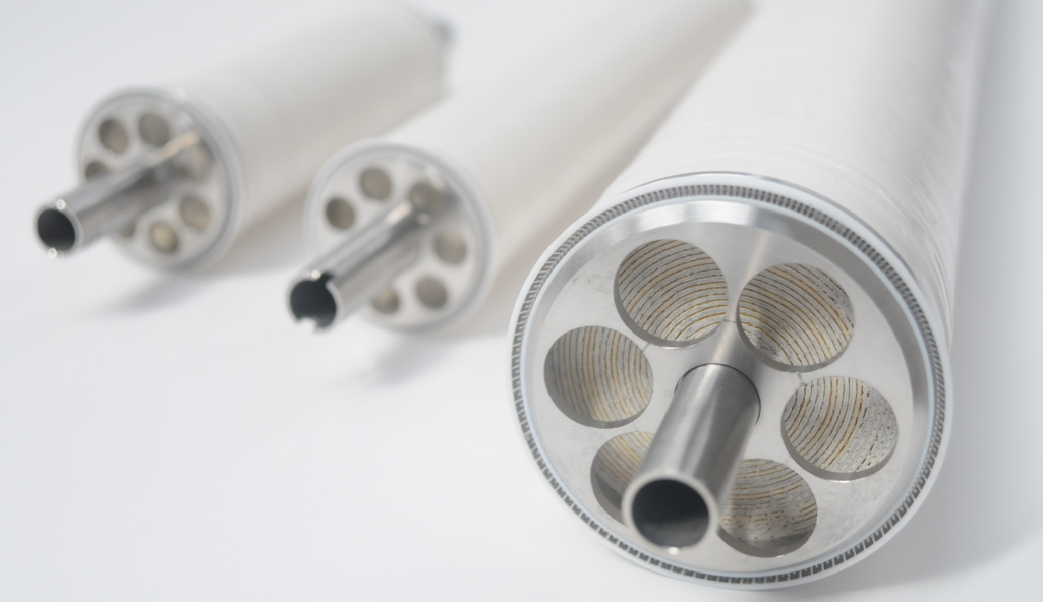

Photo caption: DuraMem® and PuraMem® - Integrate solvent-stable membrane technology.

Company information
Evonik is one of the world leaders in specialty chemicals. The focus on more specialty businesses, customer-orientated innovative prowess and a trustful and performance-oriented corporate culture form the heart of Evonik’s corporate strategy. They are the lever for profitable growth and a sustained increase in the value of the company. Evonik benefits specifically from its customer proximity and leading market positions. Evonik is active in over 100 countries around the world with more than 35,000 employees. In fiscal 2016, the enterprise generated sales of around €12.7 billion and an operating profit (adjusted EBITDA) of about €2.165 billion.

About Resource Efficiency
The Resource Efficiency segment is led by Evonik Resource Efficiency GmbH and supplies high performance materials for environmentally friendly as well as energy-efficient systems to the automotive, paints & coatings, adhesives, construction, and many other industries. This segment employed about 9,000 employees, and generated sales of around €4.5 billion in 2016.

Disclaimer
In so far as forecasts or expectations are expressed in this press release or where our statements concern the future, these forecasts, expectations or statements may involve known or unknown risks and uncertainties. Actual results or developments may vary, depending on changes in the operating environment. Neither Evonik Industries AG nor its group companies assume an obligation to update the forecasts, expectations or statements contained in this release.

