June 08, 2016

Specialized Press Contact
Janusz Berger
High Performance Polymers
Phone 49 2365 49-9227
Fax +49 2365 49-809878
janusz.berger@evonik.com

Evonik Resource Efficiency GmbH
Rellinghauser Strasse 1-11
45128 Essen
Germany
Phone +49 201 177-01
Fax +49 201 177-3475
www.evonik.com

Supervisory Board
Dr. Ralph Sven Kaufmann, Chairman
Management Board
Dr. Claus Rettig, Chairman
Dr. Johannes Ohmer,
Simone Hildmann,
Alexandra Schwarz

Registered Office: Essen
Register Court: Essen Local Court
Commercial Registry B 25783
VAT ID no. DE 815528487
Evonik starts operating membrane coating facility

Evonik Industries further steps up its activities in the attractive membrane business. The specialty chemicals company recently started operating a thin-film composites plant to coat membranes for use in organic solvent nanofiltration and gas separation at its Marl site in Germany.

Evonik is a global leader in the area of organic solvent nanofiltration, an innovative technology for particularly effective material separation in organic solvents. The Group’s hydrophobic polyimide membranes, sold under the brand names DuraMem® and PuraMem®, are used in processes such as the efficient recovery of valuable homogeneous catalysts, solvent recycling, or gentle processing of natural oils.

In the new thin-film composite plant, thin membrane films are coated with special silicone or other materials. The resulting composite membranes are then turned into solvent-resistant or gas-tight spiral-wound modules in a further production process. The corresponding silicone coating, also manufactured by Evonik, is a key factor for the separation properties of the membrane.

Access to advanced membrane technology
“The start-up of the thin-film composite plant is a consistent step in our growth plan for the attractive membrane business,” notes Dr. Matthias Kottenhahn, head of the High Performance Polymers Business Line at Evonik. “It gives our customers direct access to an advanced membrane technology for resource-efficient material separation.”

With its investment in Marl, Evonik Industries is now creating the prerequisite for the continuous expansion of its membrane portfolio with attractive new products. The Group is also using its membrane products for the optimization and new design of proprietary production processes.

New product to be launched
The start-up also marked the production launch of the third generation of DuraMem® and PuraMem® membranes. Their market introduction is planned for the second half of the current year.

Thanks to membrane coatings that are customized at the molecular level, Evonik’s membrane technology offers the advantages of lower energy consumption, higher yield, and particularly high separation precision.

For further information please visit our website at www.evonik.com/puramem

Follow us on Twitter: https://twitter.com/SepuranMembrane

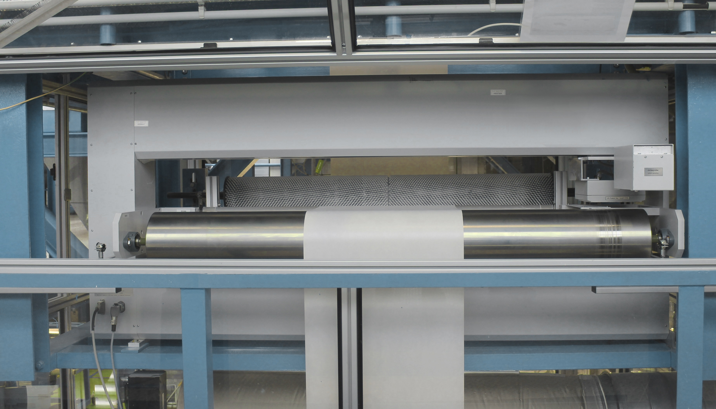

Caption: Evonik has started to operate a thin-film composites plant to coat membranes for use in organic solvent nanofiltration.

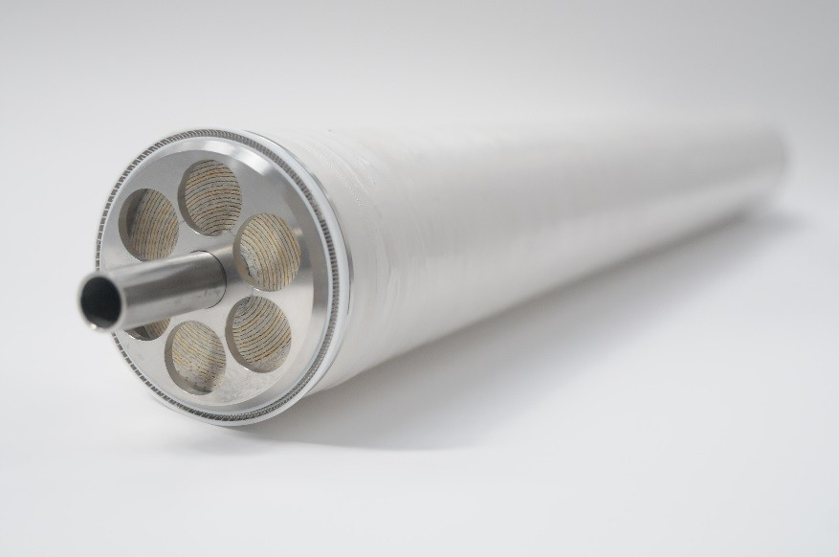

Caption: Evonik has started to produce the third generation of DuraMem® and PuraMem® membranes.

About Resource Efficiency
The Resource Efficiency segment is led by Evonik Resource Efficiency GmbH and supplies high performance materials for environmentally friendly as well as energy-efficient systems to the automotive, paints & coatings, adhesives, construction, and many other industries. This segment employed about 8,600 employees, and generated sales of around €4.3 billion in 2015.

About Evonik
Evonik, the creative industrial group from Germany, is one of the world leaders
in specialty chemicals. Profitable growth and a sustained increase in the value of
the company form the heart of Evonik’s corporate strategy. Its activities focus on
the key megatrends health, nutrition, resource efficiency and globalization. Evonik benefits specifically from its innovative prowess and integrated technology platforms.

Evonik is active in over 100 countries around the world. In fiscal 2015 more than
33,500 employees generated sales of around €13.5 billion and an operating profit (adjusted EBITDA) of about €2.47 billion.

Disclaimer
In so far as forecasts or expectations are expressed in this press release or where our statements concern the future, these forecasts, expectations or statements may involve known or unknown risks and uncertainties. Actual results or developments may vary, depending on changes in the operating environment. Neither Evonik Industries AG nor its group companies assume an obligation to update the forecasts, expectations or statements contained in this release.

