Linde and Evonik enter into strategic partnership for membrane-based natural gas processing

The technology company The Linde Group and the specialty chemicals company Evonik Industries have concluded an exclusive cooperation agreement on the use of membranes for natural gas processing. The two companies will jointly promote membrane technology – Evonik on the membrane and polymer side and Linde’s Engineering Division as the system integrator for the complete membrane package units. Evonik’s established membrane technology will serve as the basis. The joint product will be marketed by Linde as the “HISELECT™ powered by Evonik” high-performance membrane package unit.

Tobias Keller, head of the Adsorption and Membrane Plants Product Line of Linde’s Engineering Division, says: “We’re delighted to be extending our successful collaboration with Evonik to the important gas separation market of natural gas processing. HISELECT™ membranes are opening up new and innovative options in gas separation, especially in combination with our other established processes. With this, we’re consolidating our position as the world’s leading company for gas separation technologies as well as suppliers of complete separation packages.”

At the heart of the collaboration lies Evonik’s polymer-based membrane technology. The specialty chemicals company has developed this technology further for the area of natural gas and has recently commercialized it. It is the key component in Linde’s new HISELECT™ membrane, which the technology group will market globally in complete membrane package units for onshore gas separation and upgrading plants.

Dr. Axel Kobus, head of the Fibres, Membranes, & Specialties Product Line at Evonik, says: “Our latest membrane technology for upgrading of natural gas significantly expands our existing product range. We have used it to build up an attractive and powerful membrane portfolio for almost the entire gas separation market in less than 10 years, based on our polymer competencies. Our exclusive partnership with Linde in a major natural gas market strengthens our strategic positioning and reputation worldwide.”

A successful partnership in helium recovery
Linde and Evonik strengthened their collaboration in the area of membrane-based gas separation in 2016. The partnership resulted in the startup of a reference plant for helium upgrading in Mankota (Canada), which is the first ever plant of this kind to combine both separation methods, the membrane and pressure swing adsorption technologies. The plant processes more than 250,000 standard cubic meters of crude gas daily and produces industrial quality helium of 99.999% purity.

The SEPURAN® product family includes membranes for upgrading biogas, nitrogen extraction, and upgrading helium and hydrogen. These are produced at Evonik’s site in Schörfling (Austria). The neighboring Evonik site in Lenzing produces the high-performance polymer starting material.

As a leading supplier in international plant construction, Linde’s Engineering Division has already delivered more than 4,000 plants worldwide.

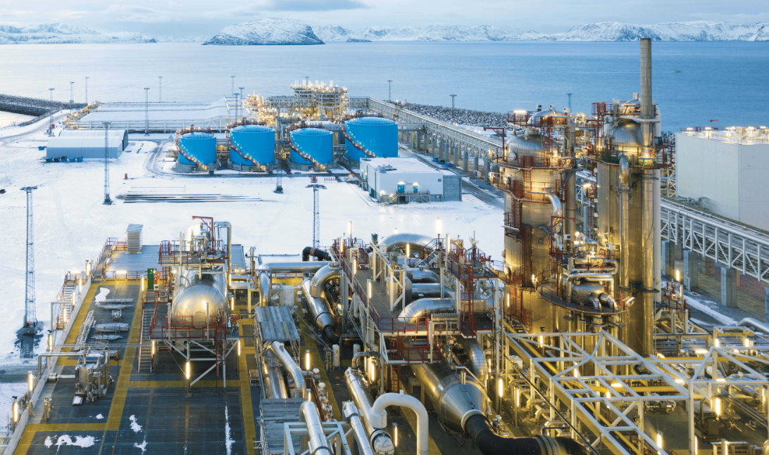
Image caption: Onshore plant for natural gas processing (© The Linde Group).

About the Linde Group
In the 2017 financial year, The Linde Group generated revenue of EUR 17.113 bn, making it one of the leading gases and engineering companies in the world, with approximately 58,000 employees working in more than 100 countries worldwide. The strategy of The Linde Group is geared towards long-term profitable growth and focuses on the expansion of its international business with forward-looking products and services. Linde acts responsibly towards its shareholders, business partners, employees, society and the environment in every one of its business areas, regions and locations across the globe. The company is committed to technologies and products that unite the goals of customer value and sustainable development.

More information about The Linde Group is available online at www.linde.com

About Evonik
Evonik is one of the world leaders in specialty chemicals. The focus on more specialty businesses, customer-orientated innovative prowess and a trustful and performance-oriented corporate culture form the heart of Evonik’s corporate strategy. They are the lever for profitable growth and a sustained increase in the value of the company. Evonik benefits specifically from its customer proximity and leading market positions. Evonik is active in over 100 countries around the world with more than 36,000 employees. In fiscal 2017, the enterprise generated sales of €14.4 billion and an operating profit (adjusted EBITDA) of €2.36 billion.

About Resource Efficiency
The Resource Efficiency segment is led by Evonik Resource Efficiency GmbH and produces high performance materials and specialty additives for environmentally friendly as well as energy-efficient systems to the automotive, paints & coatings, adhesives, construction, and many other industries. This segment employed about 10,000 employees, and generated sales of around €5.4 billion in 2017.

Disclaimer
In so far as forecasts or expectations are expressed in this press release or where our statements concern the future, these forecasts, expectations or statements may involve known or unknown risks and uncertainties. Actual results or developments may vary, depending on changes in the operating environment. Neither Evonik Industries AG nor its group companies assume an obligation to update the forecasts, expectations or statements contained in this release.

