June 18, 2018

Specialized Press Contact
Janusz Berger
High Performance Polymers
Phone +49 2365 49-9227
janusz.berger@evonik.com
Evonik Resource Efficiency GmbH
Rellinghauser Straße 1-11
45128 Essen
Germany
Phone +49 201 177-01
Fax +49 201 177-3475
www.evonik.com

Supervisory Board
Dr. Harald Schwager, Chairman
Managing Directors
Dr. Claus Rettig, Chairman
Dr. Johannes Ohmer
Simone Hildmann
Alexandra Schwarz

Registered Office: Essen
Register Court: Essen Local Court
Commercial Registry B 25783
VAT ID no. DE 815528487

Evonik launches new membrane for efficient natural gas processing
At this year’s ACHEMA in Frankfurt am Main (Germany), Evonik presented its latest membrane product development – SEPURAN® NG for efficient natural gas processing – to an international trade audience.

SEPURAN® NG is an especially robust, hollow-fiber membrane, which is based on a high-performance plastic that can withstand extreme pressure and temperatures. This enables particularly selective separation of the sour gases from the natural gas, high tolerance of the higher hydrocarbons contained in the natural gas, and consistently high performance of the membrane throughout its lifetime. Overall, Evonik’s innovative separation technology features significantly increased recovery of methane, which has a corresponding effect on the profitability of natural gas processing plants.

The modular structure of SEPURAN® NG has been designed for conventional, membrane-based natural gas processing plants so that, during the membrane exchange, no further adaptations are required to the existing equipment. For this purpose, Evonik is working together with established, world-leading gas separation companies that support plant operators in process implementation in order to make the most of the advantages of the new membranes.

Use in natural gas sources with high CO₂ concentration
The membrane is designed for the challenging process conditions of natural gas processing with complex gas compositions and typical pressure and temperature conditions up to 70 °C. It can be used particularly effectively in natural gas sources with a high concentration of carbon dioxide because, under these conditions, the separating properties of the membrane remain intact.

Evonik’s SEPURAN® product family includes innovative membranes for biogas upgrading, nitrogen generation, and helium and hydrogen processing. They are produced at the Evonik site in Schörfling (Austria). The basic material - the high-performance plastic – is manufactured in the neighboring Evonik site in Lenzing. The new SEPURAN® NG membrane for natural gas processing rounds off the product portfolio.
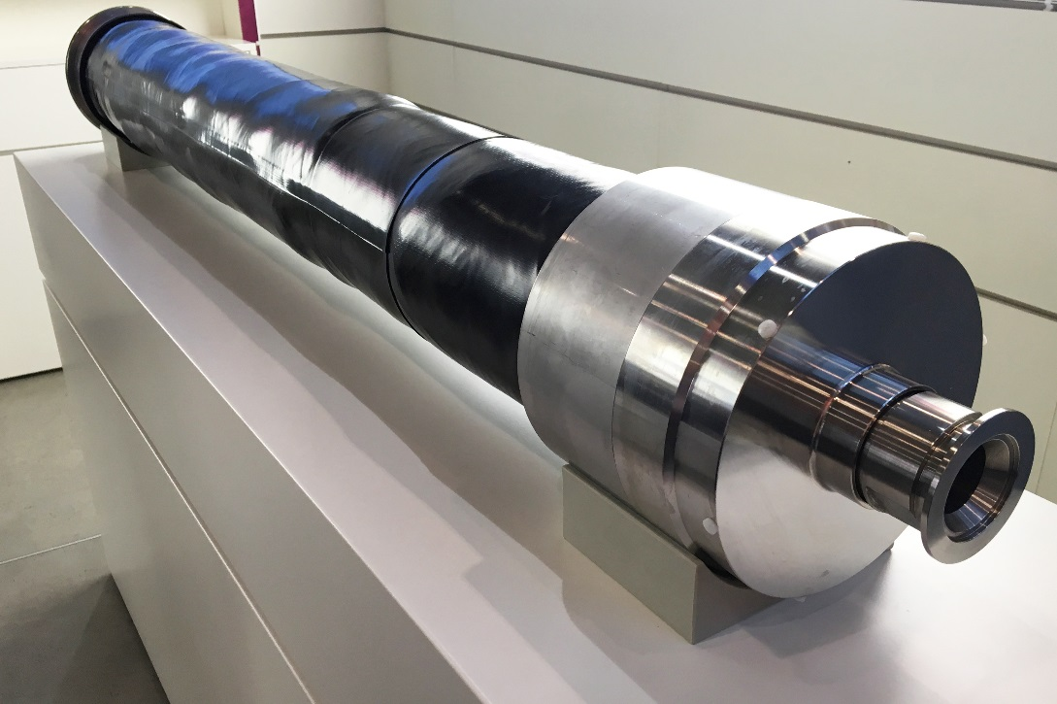

Image caption: Evonik presents its new SEPURAN® NG brand membrane for efficient natural gas processing.

More information on www.sepuran.com

About Evonik
Evonik is one of the world leaders in specialty chemicals. The focus on more specialty businesses, customer-orientated innovative prowess and a trustful and performance-oriented corporate culture form the heart of Evonik’s corporate strategy. They are the lever for profitable growth and a sustained increase in the value of the company. Evonik benefits specifically from its customer proximity and leading market positions. Evonik is active in over 100 countries around the world with more than 36,000 employees. In fiscal 2017, the enterprise generated sales of €14.4 billion and an operating profit (adjusted EBITDA) of €2.36 billion.

About Resource Efficiency
The Resource Efficiency segment is led by Evonik Resource Efficiency GmbH and produces high performance materials and specialty additives for environmentally friendly as well as energy-efficient systems to the automotive, paints & coatings, adhesives, construction, and many other industries. This segment employed about 10,000 employees, and generated sales of around €5.4 billion in 2017.

Disclaimer
In so far as forecasts or expectations are expressed in this press release or where our statements concern the future, these forecasts, expectations or statements may involve known or unknown risks and uncertainties. Actual results or developments may vary, depending on changes in the operating environment. Neither Evonik Industries AG nor its group companies assume an obligation to update the forecasts, expectations or statements contained in this release.

