Linde and Evonik intensify collaboration in the area of membrane gas separation

The technology company The Linde Group and the specialty chemicals group Evonik Industries have intensified their collaboration in the area of membrane-based gas separation within the framework of the groundbreaking ceremony for the expansion of Evonik’s membrane production facility held in Schörfling (Austria) on September 30.

The heart of the collaboration comprises Evonik's polymer-based membrane technology, which will be used in the gas separation and purification plants of Linde’s Engineering Division. With this, Linde completes its portfolio, combining all relevant gas separation processes within one company. Evonik’s SEPURAN® membranes enable gases such as methane, nitrogen, helium, and hydrogen to be particularly efficiently isolated in pure form from gas mixtures, thanks to more selective separation and higher productivity.

Tobias Keller, head of the Adsorption and Membrane Plants Product Line at Linde’s Engineering Division, says: “Evonik's high-selectivity membrane in combination with our other established gas separation technologies, such as our world-class adsorption technology, allows us an extraordinary flexibility in the development and application of new and more efficient purification processes. We are thus strengthening our position as the leading company for gas separation technologies over the entire lifecycle of a plant.”

Dr. Axel Kobus, head of Evonik’s Fibres, Membranes & Specialties Product Line, says: “The synergies arising from the collaboration between our two companies are evident: The translation of our profund polymer and technology expertise into a powerful and wide-ranging membrane product portfolio perfectly complements Linde’s high expertise in plant engineering and gas separation. The combination offers the ideal conditions to jointly develop new markets for gas separation.”

The collaboration between Evonik and Linde has already resulted in a reference plant for helium purification in Mankota (Canada), which started up in August of this year; this first-of-its-kind helium purification facility uses a hybrid process of membrane and Pressure Swing Adsorption (PSA) technology. The new plant processes 250,000 cubic meters of crude gas every day, producing industrial-quality helium of 99.999 percent purity.

As a leading player in the international plant engineering business, Linde Engineering has delivered more than 4,000 plants across the globe.

For more than 50 years the High Performance Polymers Business Line of Evonik’s Resource Efficiency Segment has been developing and producing high-performance polymers that allow new resource-efficient developments in a very wide range of fields.

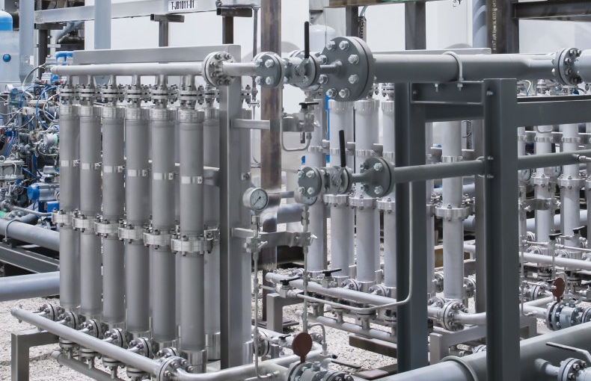
Photo caption: The picture shows membranes - a part of the helium purification facility in Mankota, Canada. (Source: The Linde Group).
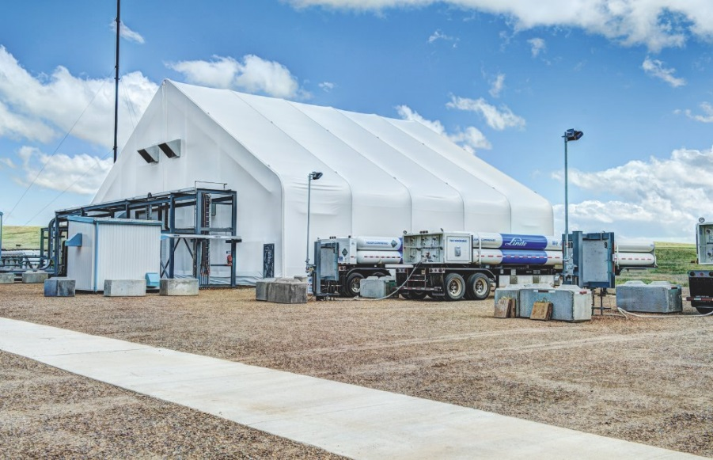

Photo caption: The picture shows the Linde engineered helium purification facility in Mankota, Canada, together with helium tube-trailers (right) for customer deliveries. (Source: The Linde Group).

The Linde Group
In the 2015 financial year, The Linde Group generated revenue of EUR 17.944 bn, making it one of the leading gases and engineering companies in the world, with approximately 65,000 employees working in more than 100 countries worldwide. The strategy of The Linde Group is geared towards long-term profitable growth and focuses on the expansion of its international business with forward-looking products and services. Linde acts responsibly towards its shareholders, business partners, employees, society and the environment in every one of its business areas, regions and locations across the globe. The company is committed to technologies and products that unite the goals of customer value and sustainable development.

For more information, see The Linde Group online at www.linde.com

About Resource Efficiency
The Resource Efficiency segment is led by Evonik Resource Efficiency GmbH and supplies high performance materials for environmentally friendly as well as energy-efficient systems to the automotive, paints & coatings, adhesives, construction, and many other industries. This segment employed about 8,600 employees, and generated sales of around €4.3 billion in 2015.

About Evonik
Evonik, the creative industrial group from Germany, is one of the world leaders
in specialty chemicals. Profitable growth and a sustained increase in the value of
the company form the heart of Evonik’s corporate strategy. Its activities focus on
the key megatrends health, nutrition, resource efficiency and globalization. Evonik benefits specifically from its innovative prowess and integrated technology platforms.

Evonik is active in over 100 countries around the world. In fiscal 2015 more than
33,500 employees generated sales of around €13.5 billion and an operating profit (adjusted EBITDA) of about €2.47 billion.

Disclaimer
In so far as forecasts or expectations are expressed in this press release or where our statements concern the future, these forecasts, expectations or statements may involve known or unknown risks and uncertainties. Actual results or developments may vary, depending on changes in the operating environment. Neither Evonik Industries AG nor its group companies assume an obligation to update the forecasts, expectations or statements contained in this release.

