April 21, 2016

Economic Press Contact
Edda Schulze
Konzerpresse
Phone +49 201 177-2225
Fax +49 201 177-3030
edda.schulze@evonik.com

Specialized Press Contact
Janusz Berger
High Performance Polymers
Phone 49 2365 49-9227
Fax +49 2365 49-809878
janusz.berger@evonik.com

Evonik Industries AG
Rellinghauser Straße 1-11
45128 Essen
Germany
Phone +49 201 177-01
Fax +49 201 177-3475
www.evonik.com

Supervisory Board
Dr. Werner Müller, Chairman
Executive Board
Dr. Klaus Engel, Chairman
Dr. Ralph Sven Kaufmann
Christian Kullmann
Thomas Wessel
Ute Wolf

Registered office Essen
Registered court
Essen local court
Commercial registry B 19474
VAT ID no. DE 811160003
Hollow-fiber membrane for efficient nitrogen separation

- Evonik has developed a new hollow-fiber membrane for obtaining nitrogen from air
- Available on the market since early 2016
- New technology is efficient, flexible, and sustainable

In SEPURAN® N₂ Evonik Industries has developed a new hollow-fiber membrane for efficient separation of nitrogen from air. The advantages of this new technology over classical cryogenic air separation as well as current membrane processes are its greater flexibility and lower costs. It can be combined with existing systems, for example to meet peak demand, or directly connected to compressed air systems to supply nitrogen. In addition, Evonik’s SEPURAN® N₂ membranes offer a lower-cost solution than other membranes due to the high capacity and low air requirement. The new technology from Evonik has been on the market since early 2016.

As an inert gas of low reactivity, nitrogen is used as a protective gas in many sectors of industry; in the food industry or in the aerospace industry to inert the fuel tanks of planes and create a flame-resistant atmosphere. With a market share exceeding 40 percent, nitrogen has the highest market volume in the gas separation sector.

Goetz Baumgarten, who is responsible for global SEPURAN® business in Evonik’s Resource Efficiency Segment, says: “With SEPURAN® N₂ we plan to extend our technology position in customized membrane gas-separation systems.” The SEPURAN® N₂ hollow-fiber membrane at the heart of the technology consists of polyimide, a high-performance polymer that is highly chemically and thermally stable, and is produced by Evonik at its Lenzing (Austria) site. The hollow fibers, which resemble long and very thin tubes of pasta, are bundled together, embedded in a resin developed specially for the purpose, and enclosed in a stainless steel module. The membrane module, approximately 1.3 m long, contains several tens of thousands of these fine tubes, each of diameter 0.5 mm.

For separation of nitrogen, compressed air is fed into the hollow-fiber membranes. Air has two main components, consisting of up to 78 percent nitrogen and 21 percent oxygen. Due to their smaller size, oxygen molecules can pass through the membrane more easily than nitrogen molecules. This leads to enrichment of nitrogen to the desired purity inside the hollow fibers, while an O₂-rich airstream is generated on the outside. The purity of the N₂ can be regulated via the flow rate of the incoming air: The lower this flow rate, the higher is the quality of the nitrogen. For many applications technical nitrogen of purity 95 to 98 percent is adequate. This is where the new Evonik technology stands out.

Compared with other conventional membrane systems the new technology requires fewer modules and less air. A smaller compressor reduces investment costs as well as energy consumption and the modular structure means that the system can be used flexibly. Says Baumgarten: “SEPURAN® N₂ is efficient and flexible. This membrane module from Evonik is distinguished by low investment costs, very low operating costs, and low maintenance expenditure.”

As a technology leader in high-performance polymers, the specialty chemicals group has developed over the years a wide variety of membrane systems for efficient gas separation. SEPURAN® Green, for example, is used in biogas upgrading because it separates carbon dioxide and methane gas very efficiently. More than 70 biogas upgrading systems globally have been fitted with SEPURAN® Green membrane modules.

Currently, Evonik is expanding its Austrian site in Lenzing/Schörfling to double the existing production capacities for the hollow-fiber membrane modules of its SEPURAN® brand. The production of additional membrane modules is projected to begin in late 2017.

Capture: Efficient nitrogen separation using hollow-fiber membranes. In SEPURAN® N2 Evonik Industries has developed a new hollow-fiber membrane for efficient nitrogen production.

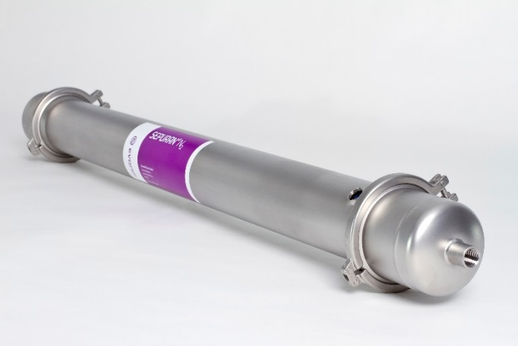

Capture: SEPURAN® N2 cartridge

Company information
Evonik, the creative industrial group from Germany, is one of the world leaders
in specialty chemicals. Profitable growth and a sustained increase in the value of the company form the heart of Evonik’s corporate strategy. Its activities focus on the key megatrends health, nutrition, resource efficiency and globalization. Evonik benefits specifically from its innovative prowess and integrated technology platforms.

Evonik is active in over 100 countries around the world. In fiscal 2015 more than 33,500 employees generated sales of around €13.5 billion and an operating profit (adjusted EBITDA) of about €2.47 billion.

About Resource Efficiency
The Resource Efficiency segment is led by Evonik Resource Efficiency GmbH and supplies high performance materials for environmentally friendly as well as energy-efficient systems to the automotive, paints & coatings, adhesives, construction, and many other industries. This segment employed about 8,600 employees, and generated sales of around €4.3 billion in 2015.

Disclaimer
In so far as forecasts or expectations are expressed in this press release or where our statements concern the future, these forecasts, expectations or statements may involve known or unknown risks and uncertainties. Actual results or developments may vary, depending on changes in the operating environment. Neither Evonik Industries AG nor its group companies assume an obligation to update the forecasts, expectations or statements contained in this release.

